Ex.No. : 4
Date:

Aim:

DML Commands with Constraints –UPDATE, DELETE

To perform Data Manipulation Language (DML) Commands such as UPDATE, DELETE in the table.

Description:

Data Manipulation Language (DML) statements are used for managing data within schema objects. DML Commands: Update, Delete
- UPDATE - updates existing data within a table
- DELETE - deletes all records from a table, the space for the records remain

UPDATE:
UPDATE table_name
SET column1=value, column2=value2,... WHERE some_column=some_value;

DELETE:
DELETE FROM table_name WHERE some_column=some_value;

Questions:
- Update the employee name whose Employee ID is 2601.Delete the record in the table FACULTY, who resigned her job.
- Update the department of the employee whose Employee ID is 2602.Remove all faculty who are having over 65 years

3. Update the phone number of the employee whose Employee ID is 2603.

OUTPUTS:
1)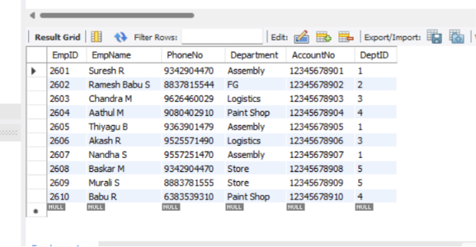

2)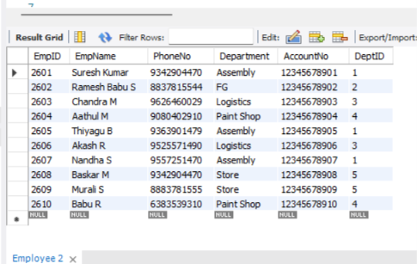

3)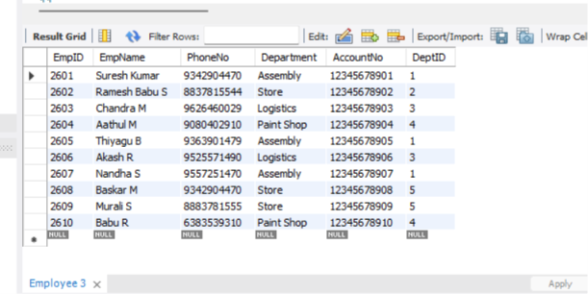

4)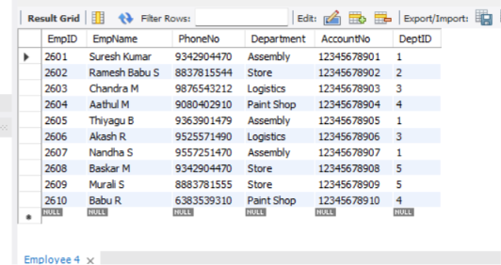

5)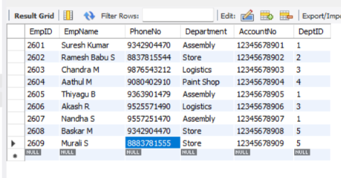

RESULT:

Data Manipulation Language (DML) Commands such as UPDATE, DELETE are performed in the five tables.

